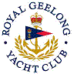 | Royal Geelong Yacht Club Inc.  Est 1859
Trophy Deed of Gift.

Trophy: | Associates’ Trophy
Presented by: | Associates’ Committee
Date:
For: | Event So Named
Remarks / Revisions | Presented on the day named Associates’ Day

